Embed air you see delete that is leave the file open and ship it will just record this type stand and all this information for me the author and everything this is a watermark it's there's a this is my smart contract implementation watermark inflated details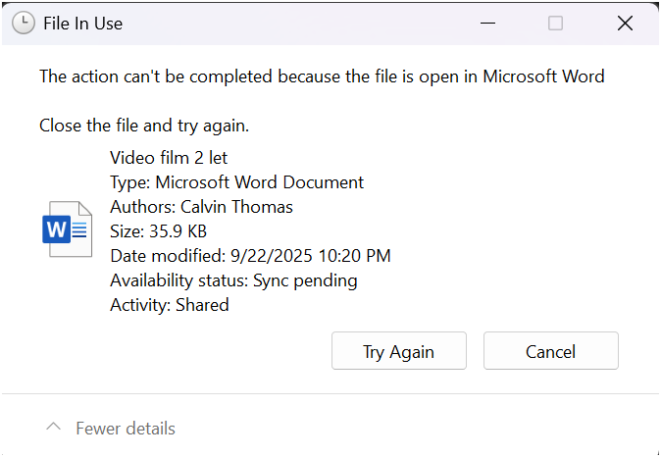Delete method. Ohh OK get up look at this \*\*\*\*. I literally just paste in an empty text box space OK? IMG or some incompatible file format or whatever and then that's it and then that saves that ship i just thought it physically i physically just thought that ship and that's gone let's say that's how digital footprints work public digital footprint Video film 2 let's try this out notification deleted this is another method i'm using a link that i literally just deleted and i copied the ship that i deleted so there's not no there's always a paper trailA computer screen with a black screen
